HOSA WINTER LEADERSHIP CONFERENCE (WLC)/ REGIONAL COMPETITION

Saturday,January 21, 2023

Middleton High School

4801 N. 22nd Street,Tampa

* Arrival Time – PHUHS Bus Circle: 7:45 am
* HOSA Uniform: ladies scarf is optional

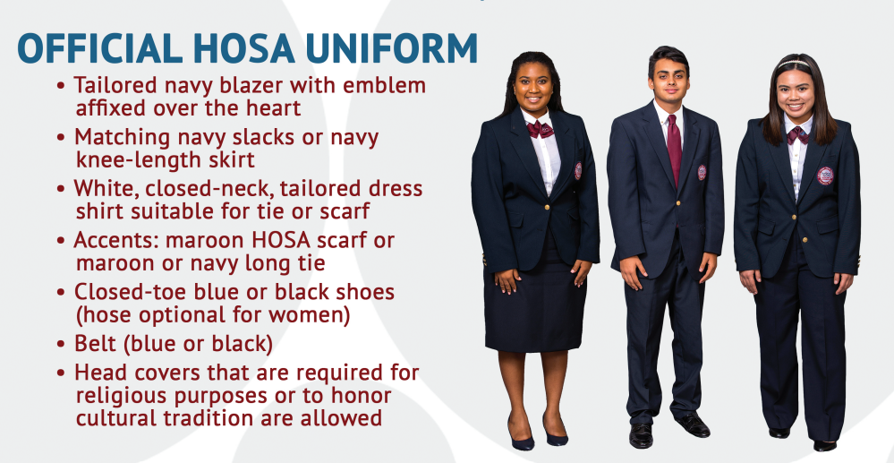

* + HOSA pin
  + Skills Only Competitions: check competitive event guidelines for acceptable dress requirements
* Food:
  + Food Trucks will be on site; lines are long
  + Recommendation: bring lunch, snacks, drinks
* Remember to bring:
  + Printed copy of competitive event guidelines
    - hosa.org > Competitions tab > Guidelines
  + Each competitive event has a box, such as the one below, listing the supplies that the competitor is required to bring to their event (supply list is unique to/different for each event) – please reference this list (medical teachers can help, by appointment)

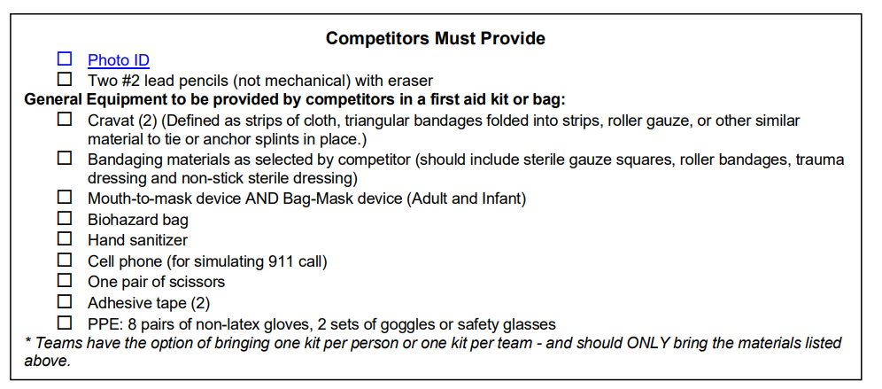

* + Laptops & chargers for presentations
  + Extra batteries for any electronic accessories
  + Events requiring Tallo uploads:
    - This only applies to state and international competition
    - Bring hard copies of everything! (bringing digital files to have on hand couldn’t hurt)
* Competitors should:
  + Pay close attention to title page requirements (if applicable to event; medical teacher can assist)
  + Ensure that the official HOSA binder is being used (if applicable to event; binder check-out is available in Mrs. Webb’s classroom: 3-206)
  + Listen for (in the Opening Session) and look for (posted in the Conference Registration) any room changes for competitive events
  + Report to competition room immediately following the Opening Session & remain directly outside of the competition room until your name/group is called in to compete
    - use this time to study/practice!
* Awards ceremony
  + Top 5 Competitors/Teams will be announced
  + Top 3 Competitors/Teams advance to the Florida State Leadership Conference (SLC) April
* HOSA State Leadership Conference (SLC): Thursday, April 13 – Sunday, April 16
  + $250 (hotel, conference registration)/student – Online Payment Due January 29, 2023

Tentative Conference Schedule

Opening Ceremony: 9:00AM - 9:30AM

Competitions: 10:00AM - 4:00PM

Closing Ceremony 4:00PM - 5:00PM

Media Center

10:00AM -12:30PM Health Career Display Round 1; 12:30PM -1:00PM Judges Lunch Break

1:00PM - 3:30PM Health Career Display Round 2

Auditorium 10:00AM -12:00PM Medical Spelling

Room 303

10:00AM - 2:00PM CPR/First-Aid

2:30PM - 4:00PM Job Seeking Skills

Room 306

10:00AM-12:00PM Pharmacy Science

12:30PM - 4:00PM Research Poster

Room 307

10:00PM - 2:00PM Emergency Medical Technician

2:30PM - 3:00PM Speaking Skills

Room 308 10:00AM -12:30PM Creative Problem Solving Preparation

Room 310

10:00AM -12:30PM Creative Problem Solving Preparation

1:00PM - 3:00PM Mental Health Promotion

Room 312 10:00AM - 1:30PM Prepared Speaking

Room 314 10:00AM - 12:30PM Medical Innovation

Room 315 10:00AM - 2:30PM Biomedical Debate Competition

Room 316

10:00AM -12:30PM Public Health Round 1; 12:00PM - 12:30PM Judges Lunch Break

12:30PM - 3:30PM Public Health Round 2

Room 317

10:00AM -2:30PM Biomedical Debate Holding Area

Room 318

10:00AM -11:30PM Extemporaneous Writing

12:00PM - 2:00PM Health Career Photography

Room 319 10:00AM - 2:00PM Public Service Announcement

Room 320

10:00AM - 12:00PM Parliamentary Procedures

12:30PM -3:30PM Researched Persuasive Writing and Speaking

Room 331

10:00AM -11:00AM Forensic Science

11:30AM- 3:00PM Clinical Nursing

Room 334 10:00AM - 1:00PM Sports Medicine

Room 336 10:00AM - 2:30PM Biotechnology

Room 337 10:00AM - 1:30PM Physical Therapy

Room 338

10:00AM - 1:00PM Family Medicine Physician

1:30PM - 3:30PM Healthy Lifestyle

Room 339 10:00AM - 12:00PM Dental Science

Room 340

10:00AM - 12:00PM Veterinary Science

12:30PM - 3:30PM Medical Assisting

Room 341

10:00AM - 12:30PM Clinical Laboratory Science

12:30PM - 1:00PM Personal Care

Room 342

10:00AM - 12:00PM CERT Skills

12:30PM - 3:00PM Clinical Nursing

Room 344 10:00AM - 2:00PM Health Education

Room 345

10:00AM - 11:00AM Clinical Specialty

11:30AM - 2:00PM Community Awareness

Room 347

10:00AM -12:00PM Home Health Aide

12:30PM - 1:00PM MRC Partnership

Room 348

10:00AM - 2:30PM HOSA Bowl Competition Room 350

10:00AM - 2:30PM HOSA Bowl Competition Holding Area